Logical Volume Management (LVM)

Tasks

1. Create two 200MB partitions using fdisk or parted, then use the lsblk command to verify their creation.

ANS:

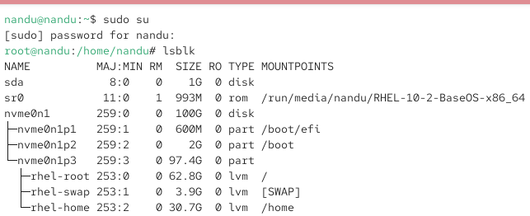

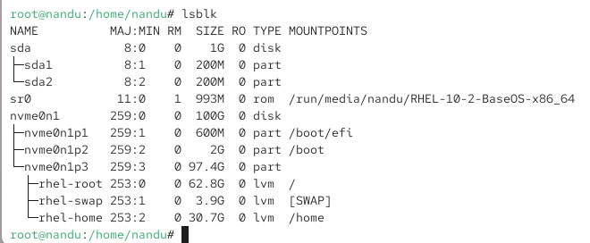

2. Initialize both partitions as physical volumes using the pvcreate command and confirm their status with pvs.

ANS:

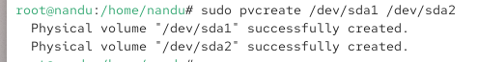

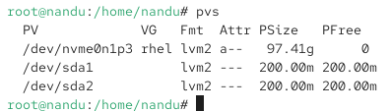
3. Create a new volume group named musicvg using the two physical volumes, then display its details with vgdisplay.

ANS:

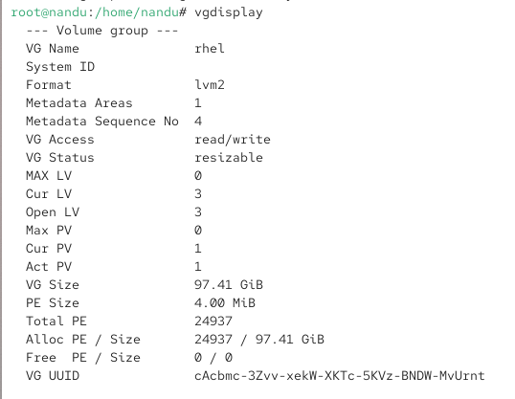

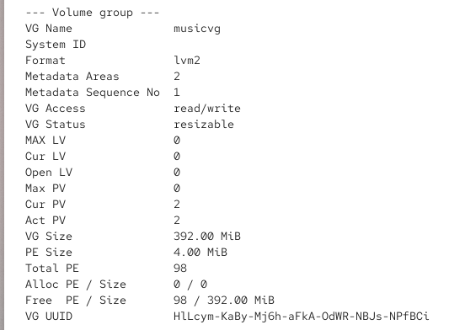

4. Create a logical volume called playlistlv of size 300MB inside musicvg, format it with ext4, and mount it to /mnt/playlist.

ANS:

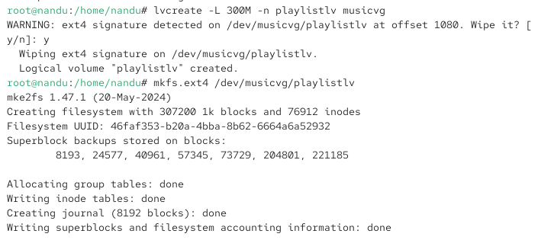

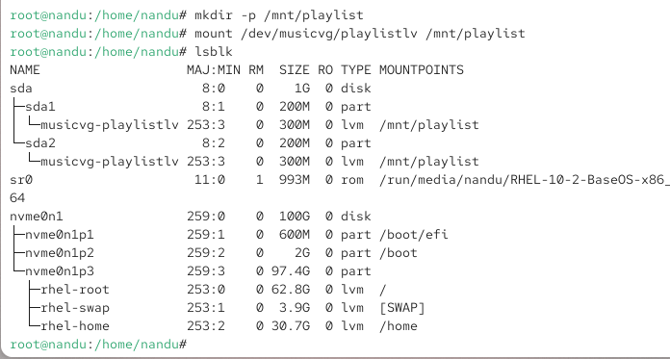

5. Resize playlistlv by adding 50MB more space using lvextend, then expand the filesystem and show the updated size with df -h. Use resize2fs after lvextend to update the filesystem size.

ANS:

